Project Name: | Berry to Bomaderry Princes Highway Upgrade |  | Project No: | 021806
Enviro Representatives Name: |  | Jacqueline McKenzie | Date: | 4/11/2019
1. Project Environmental Summary (Provide brief dot points on environmental aspects – Soil & Water, Flora & Fauna, Noise & Vibration, Cultural Heritage, Contaminated soil, etc.)
- Example: No clearing of native vegetation has occurred outside project corridor as part of the initial works. No exceedance in dust monitoring results.

- Most of the rainfall for October fell in the first half of the month with the second half of the month generally dry and a total of 65.4 mm for October
- Night works were undertaken from 21 – 31 October for the lateral shift. Complaints were received from 3 residents during this period, offers of alternate accommodation were declined by these residents both prior to and after the complaints were lodged
- Scour rock rework has commenced in Flying Fox Creek to install the new creek design to permit fish passage during operation of the project. Rework of other creeks will commence in the coming weeks and months
- Culvert demolition has commenced along the old section of highway near Ison Lane. Cut timbers have been found in the fill around and below these culverts and the Unexpected Finds Procedure has been implemented. Heritage investigations are ongoing
- Dust management is an ongoing issue, particularly along haulage routes and during drilling and excavation of rock for the retaining wall construction at Strongs Road
- Bridge deck concrete pours have continued through October without incident at a number of bridges
- Piling was completed without incident at Abernethys Creek and has commenced at Tullian Creek for bridge construction at these locations.
- No major environmental incidents occurred in the month, however, one incident involving access to site prior to 7am indicates awareness and compliance with approved working hours is an ongoing issue.

2. Environmental Training (Provide brief dot points on training completed throughout the month)
- Example: Spill Response Training by XYZ Pty Ltd, Toolbox Talk on Dust Management

- Road to completion workshop held on 25/10/19 to workshop what success looks like with DSWJV and RMS for the project and incorporated discussion around safety, environmental and quality objectives.

3. Audit and Inspection Summary
Audit Type | No. This Month | No. of Actions Items raised | No. of Outstanding Actions
Internal | 1 | 4 | 0
External (Client / EPA / Others) | 0 | 0 | 0
Inspection Type | No. This Month | No. of Actions Items raised | No. of Outstanding Actions
Internal | 11 | 9 | 2
External (Client / EPA / Others) | 3 | 18 | 1
3.1 Brief Summary of Outstanding Action

- RMS inspection actions primarily related to maintenance of ERSED, including clean and dirty water separation maintenance of sediment fences and tidying of batters and stockpiles
- Internal audit raised 4 actions, three relating to close out of incident documentation, and one relating to records of Project Soil Conservationist inspections. All audit actions have been closed out.

4. Environmental Risks (Summarise the top three environmental project risks for next month. Only update when a change or review occurs):)
Risk # | Risk Description
1 | ERSED - New areas of work and works within creeks undertaken as Portion 2 works commence. Ensure ESCP, Permit to Clear and EWMS are current/approved, understood and all requirements implemented.
2 | Alternating wet and dry periods leading to wet weather complacency and ERSED risk. Ensure site teams understand and implement ESCP controls and that ESCPs are up to date with current work staging
3 | Hot weather leading to dry conditions and dust generation. Ensure areas are stabilised as early as possible and dust suppression is used where needed.

5. Environmental Initiatives and Photos
5.1 Initiatives (Summarise any environmental initiatives that the project team has taken throughout the month)
- Example: Bus tours for community groups with large focus being given to environmental issues

- Residents who are affected by noise impacts of night-time work and are not able or willing to accept offers of alternative accommodation, have been provided noise cancelling headphones to provide some respite from impacts.

5.2. Photos (Provide photos of activities throughout the month that demonstrate good environmental practices)
- Example: Implementation of best erosion and sediment control practices.

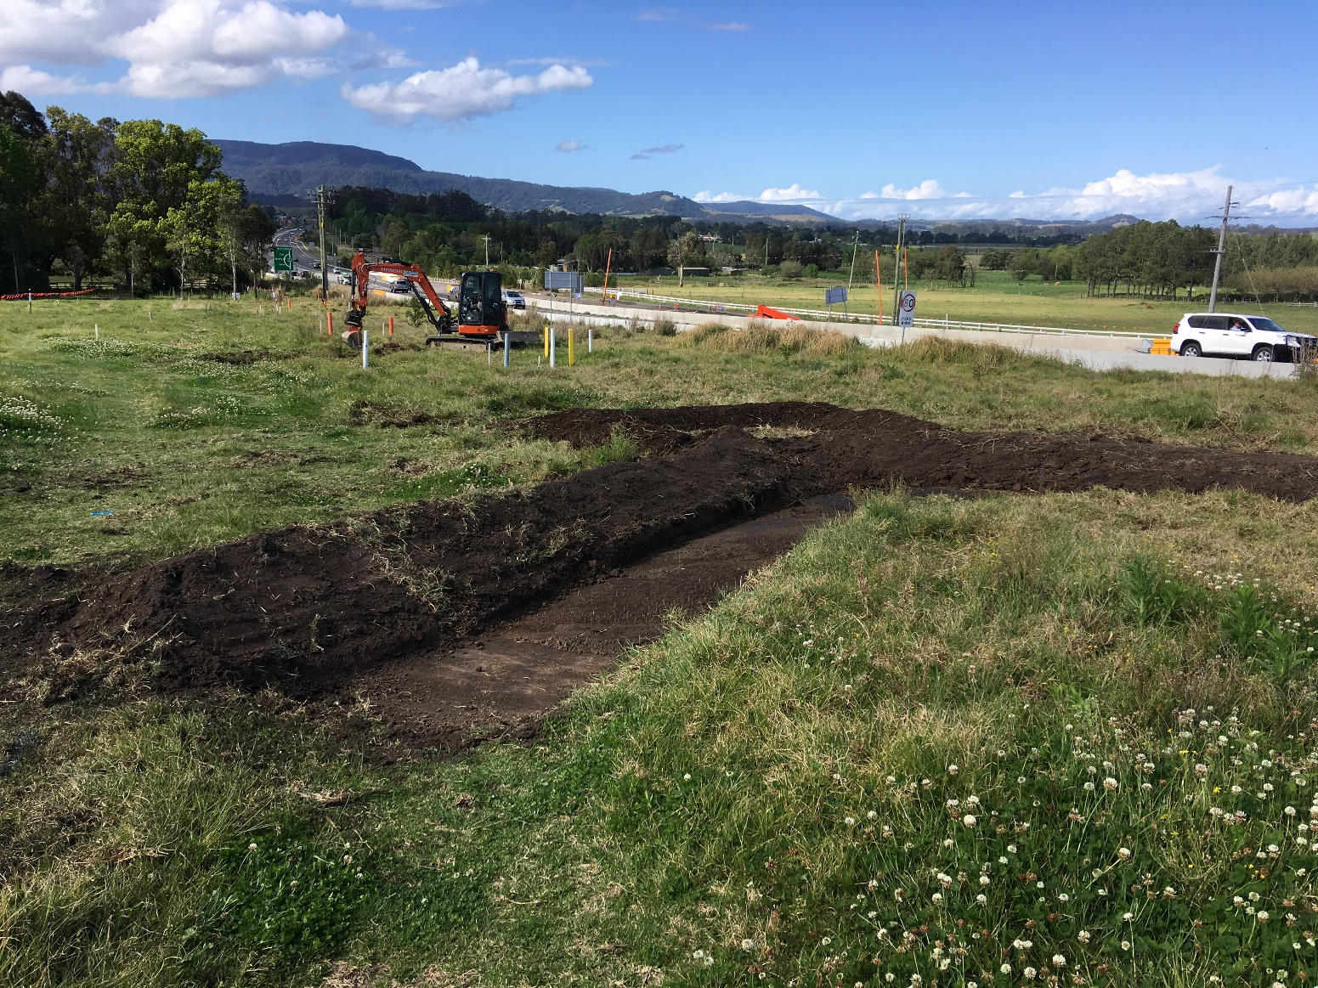
Installation of sediment controls at Croziers Road prior to topsoil stripping.
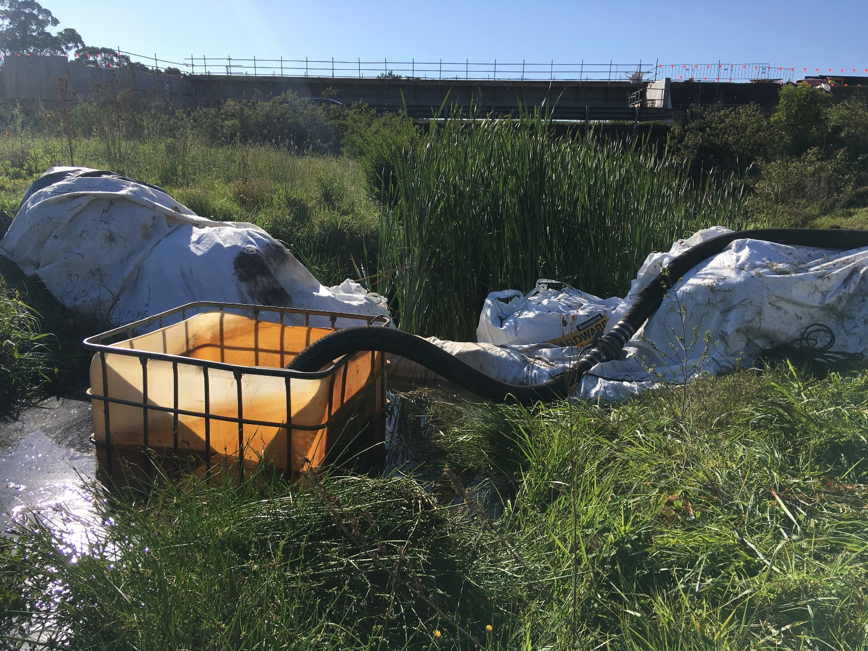
Overpumping of Flying Fox Creek to enable construction of revised permanent scour rock design in creek.
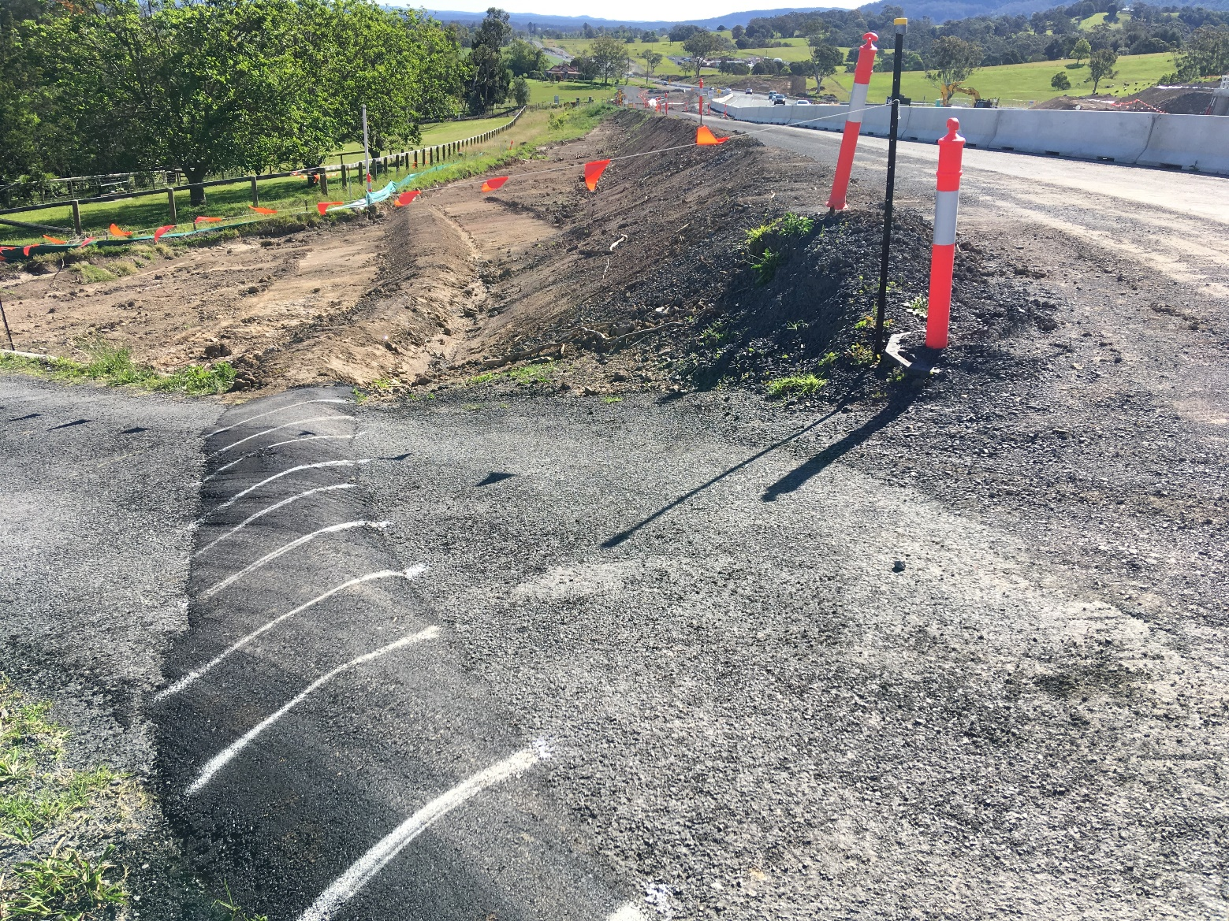
Clean water diversion across resident access road
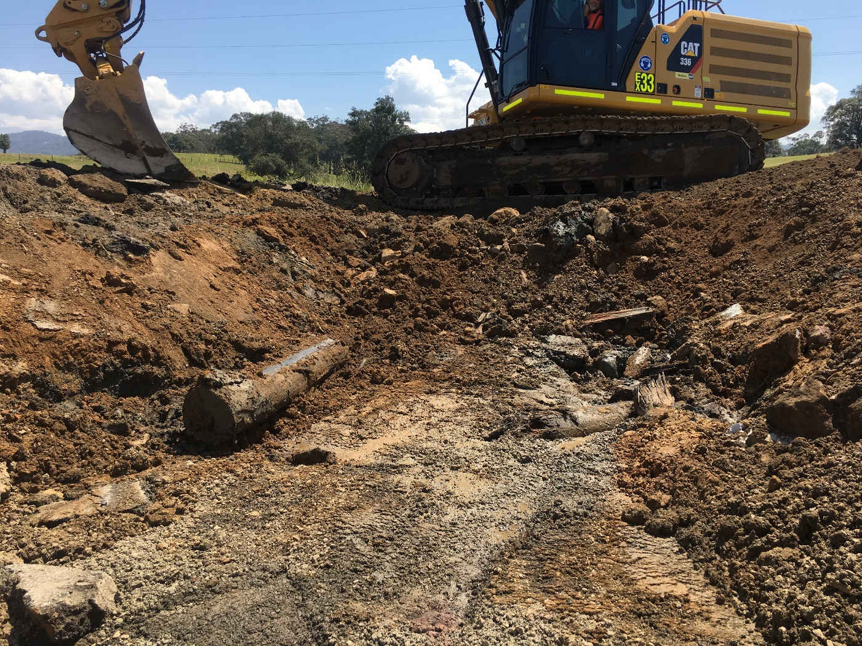
Cut timbers found during excavation of old Princes Highway culverts

6. Environmental Non-Conformance (ENCR’s)
- Example: Monthly frog survey was not undertaken as per the EPBC approval condition. 6.8.2.

- Access to construction site at Lamonds Lane prior to approved working hours without an approved OOHW Permit

7. Other Details (Free text) Add additional information to suit client’s reporting requirement
- Example: Clearing of 350 square meters of native grass within the corridor as per the EPBC approval conditions

- [text]

