Tamworth Monitoring Data
Licensee: | Downer Edi Works Pty Ltd | Address: | 15-27 Armstrong St Tamworth NSW 2340 | EPL No. | 12118
Sampled: | 11/02/13 | Obtained: | 18/02/13 | Published: | 21/02/13
Sampling Point | Monitoring frequency as per licence | Pollutant | Result | Discharge Limit | Unit
Outlet Point 2 | Discharge after bypass of first flush system. | Suspended Solids | 58 | 50 | mg/L
Outlet Point 2 | Discharge after bypass of first flush system. | Oil & Grease | < 5 | 10 | mg/L

The first flush system is regularly maintained to minimise any discharge from site and drain wardens are installed in all of the sites drains to reduce suspended solids. This test indicates slightly higher than expected suspended solids which will be improved with an increase focus on reducing the sediment on the sites pavement.

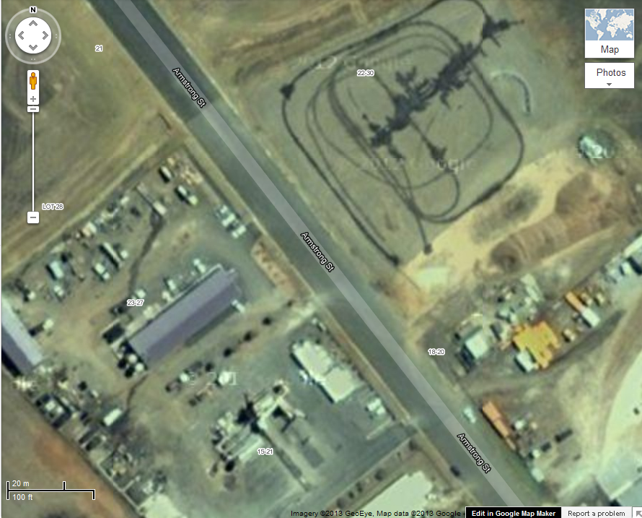
Outlet Point 2

