Tamworth Monitoring Data
Licensee: | Downer Edi Works Pty Ltd | Address: | 15-27 Armstrong St Tamworth NSW 2340 | EPL No. | 12118
Sampled: | 03/06/13 | Obtained: | 13/06/13 | Published: | 17/06/13
Sampling Point | Monitoring frequency as per licence | Pollutant | Result | Discharge Limit | Unit
Outlet Point 2 | Discharge after bypass of first flush system. | Suspended Solids | 46 | 50 | mg/L
Outlet Point 2 | Discharge after bypass of first flush system. | Oil & Grease | < 5 | 10 | mg/L

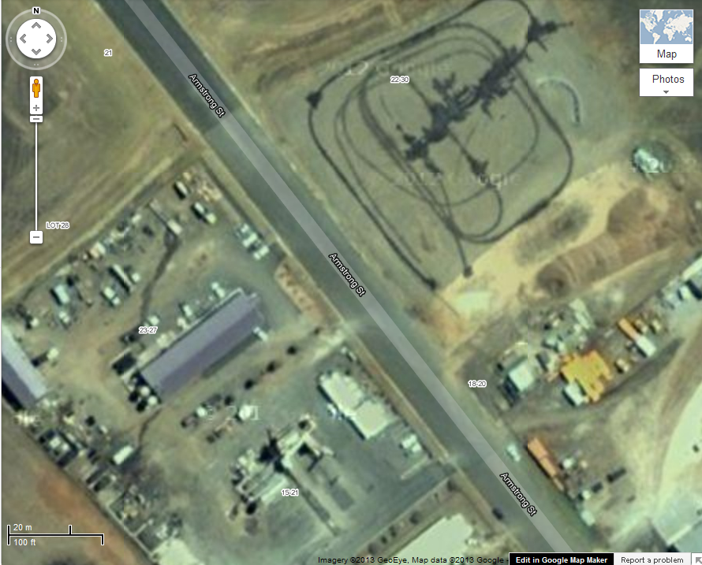
Outlet Point 2

