Tamworth Monitoring Data
Licensee: | Downer Edi Works Pty Ltd | Address: | 15-27 Armstrong St Tamworth NSW 2340 | EPL No. | 12118
Sampled: | 6/11/14 | Obtained: | 17/11/14 | Published: | 02/12/14
Sampling Point | Monitoring frequency as per licence | Pollutant | Result | Discharge Limit | Unit
Outlet Point 2 | Discharge after bypass of first flush system. | Suspended Solids | 72 | 50 | mg/L
Outlet Point 2 | Discharge after bypass of first flush system. | Oil & Grease | 10 | 10 | mg/L

Comment
This test indicates higher than expected suspended solids. An investigation is currently underway to determine an appropriate upgrade to the current water treatment system. Housekeeping and drain protection systems will remain a high priority.

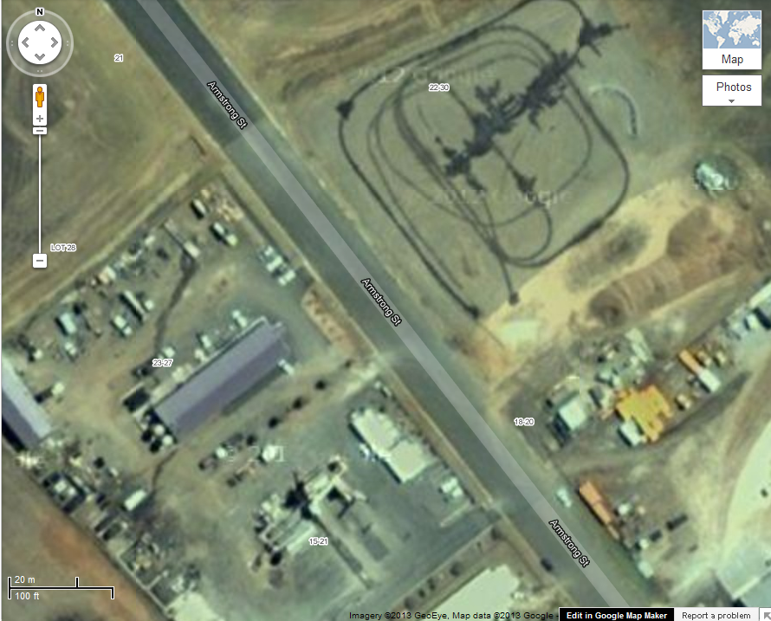
Outlet Point 2

