Tamworth Monitoring Data
Licensee: | Downer Edi Works Pty Ltd | Address: | 15-27 Armstrong St Tamworth NSW 2340 | EPL No. | 12118
Sampled: | 18/08/14 | Obtained: | 27/08/14 | Published: | 09/09/14
Sampling Point | Monitoring frequency as per licence | Pollutant | Result | Discharge Limit | Unit
Outlet Point 2 | Discharge after bypass of first flush system. | Suspended Solids | 72 | 50 | mg/L
Outlet Point 2 | Discharge after bypass of first flush system. | Oil & Grease | 11 | 10 | mg/L

Comment
This test indicates higher than expected oil and grease for the first time and suspended solids. The drain protection system was immediately replaced and an investigation is currently underway to determine if the new aggregate source and/or altered vehicle movement plan has any impact on water quality.

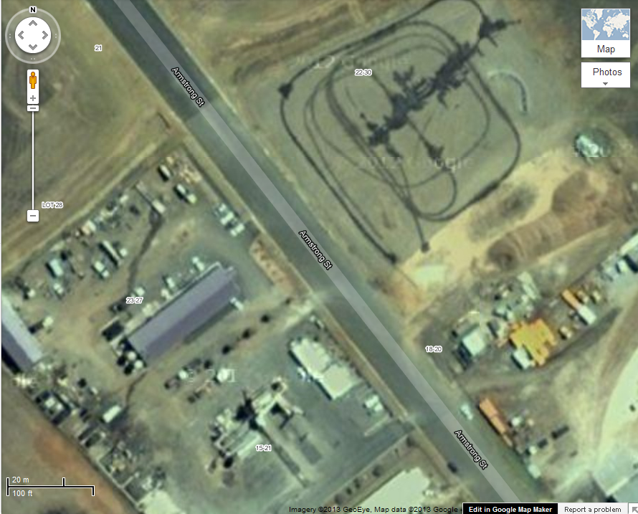
Outlet Point 2

